**Data Movement’s Follow the Sun (FTS) - Handoff Tool & Process**

**Guide for Support Engineers**

This Guide assumes the following:

* You are a support engineer active on VDM.
* You’re familiar with the current [Big Data / Data Movement handoff process](https://dev.azure.com/Supportability/Big%20Data/_wiki/wikis/Big-Data.wiki/306262/Case-Handoff-Process)

How to Access the FTS Tool

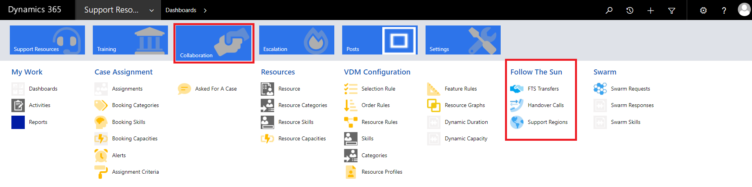

1. In Edge Browser:  [https://crmglobal.corp.microsoft.com/GLBCRMSUP/](https://crmglobal.corp.microsoft.com/GLBCRMSUP)
2. Go to **Collaboration**, then **FTS Transfers** under “**Follow The Sun**” title

Cases Automatically Added to FTS

Cases that meet the criteria below will be automatically added to the FTS list to be approved for transfer.

* Sev A “CritSit” cases not marked as “Waiting for Confirmation”
* Sev B and 27x7 flagged cases not marked as “Waiting for Confirmation”

How to Add a Case to Transfer

Steps to add your case to the transfer list.

1. Open CRM in Edge Browser:
2. Search your case number in the search bar on the top right.  
   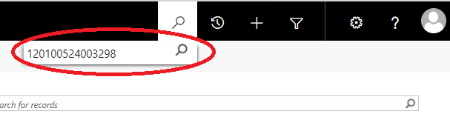
3. Select your case under “Service Requests”  
   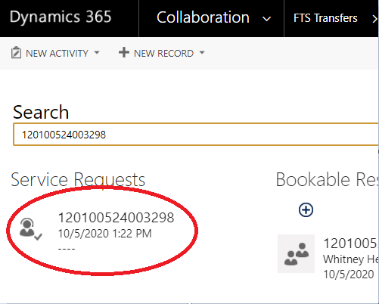
4. In the top bar, click the drop-down next to the case number.  
   
5. Select “FTS Transfers”  
   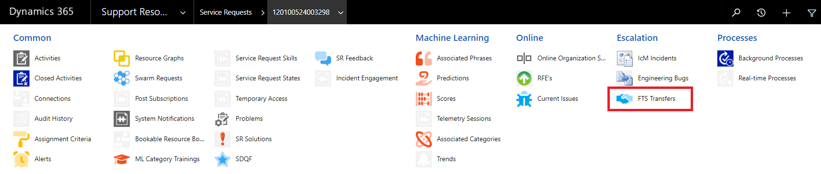
6. Select “+ Add New FTS Transfer”  
   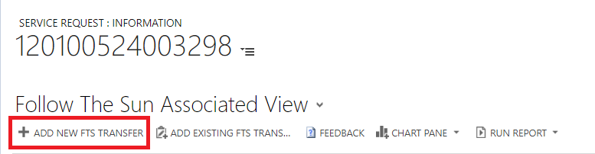
7. Fill out the FTS form with the appropriate information.  
   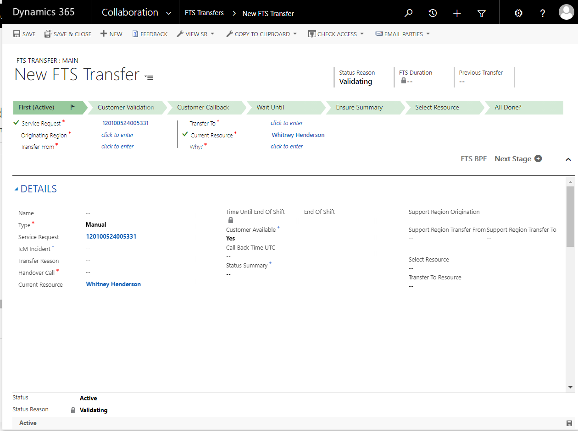

How a Case is Transferred After It Has Been Added

A case that has been added, automatically or manually, to the list will be approved for transfer by a lead.

After it has been approved for transfer VDM will find a skilled engineer in the destination region and will automatically assign that engineer, like for any other case.

If a case has been previously transferred, FTS will favor transferring to an engineer who has owned the case in the past.

Handover Calls

Handover calls still exist and are an integral part of FTS.

If a case slated for handover needs to be discussed, the handover call will be the teams chat/location to facilitate the discussion, much as our calls today.  
  
When we initialize FTS, the handoff calls should be joined to make sure cases are appropriately transferred.  
  
As we become familiar with the process, the handover calls can be used to facilitate discussion of more interesting cases.